Carlton on Trent Parish Council

Casual Vacancy for a Parish Councillor

NOTICE IS HEREBY GIVEN in accordance with Section 87(2) of the Local Government Act 1972 that a vacancy exists in the office of Parish Councillor for Carlton on Trent Parish Council.

The vacancy has arisen due to the resignation of June Mear and their term of office would have ordinarily expired in May 2027.

An election to fill the vacancy will be held if within 14 days* from the date below, TEN electors who are included on the Register of Electors at an address in the Parish, give notice in writing claiming such election to: -

The Returning Officer
Castle House
Great North Road
Newark
NG24 1BY

If no such notice is given, The Returning Officer will notify the Parish Council, who may then fill the vacancy by co-option.

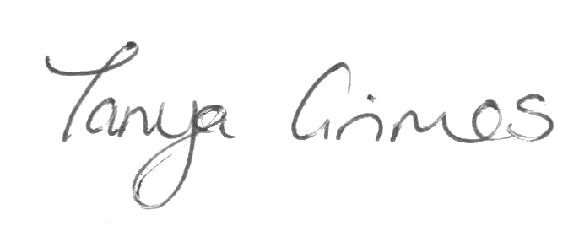

Signed:

Clerk to Carlton on Trent Parish Council.

Dated: 15th September 2025

*Not counting Saturdays, Sundays, Christmas Eve, Christmas Day, Good Friday or Bank Holidays.

